

**DEPARTMENT OF MATHEMATICS**

**PROJECT RECORD**

**ON**

**A COMPREHENSIVE ANALYS OF FINANCIAL PERFOMENCE INSIGHTS A LEAD BANKS**

* **DATA ANALYTICS WITH TABLEAU**

**TAMILNADU SKILL DEVELOPMENT CORPORATION, GOVERNMENT OF TAMILNADU,**

**NAAN MUDHALVAN PROGRAM**

**Submitted**

**By**

**1.N.PANDIMEENA (222006461)**

**2.K.DEVADARSHINI(222006448 )**

**3.V.KARTHIKA(222006455)**

**4.G.KAVYA BHARATHI(222006457)**

**(III B.Sc MATHEMATICS)**

**CERTIFICATE**

THIS IS TO CERTIFY THAT THE PROJECT IS TITLED  **ACOMPREHENSIVE ANALYS OF FINANCIAL PERFOMENCE INSIGHTS A LEAD BANKS** THIS PROJECT IS SUBMITTED BY N.PANDIMEENA (222006461),V.KARTHIKA(222006455), OF III B.SC MATHEMATICS, Dr.MGR JANAKI COLLEGE OF ARTS AND SCIENCE FOR WOMEN, CHENNAI IN FULFILLMENT OF THE REQUIREMENTS FOR **TAMILNADU SKILL DEVELOPMENT CORPORATION, GOVERNMENT OF TAMILNADU,NAAN MUDHALVAN PROGRAM**. THIS PROJECT WAS AN AUTHENTIC WORK DONE BY HIM UNDER MY SUPERVISION AND GUIDANCE.

 

**PROJECT GUIDE HOD**

**TABLE OF CONTENTS**

|  |  |  |
| --- | --- | --- |
| **S.NO** | **CONTENTS** | **PAGE NO** |
| **1** | **INTRODUCTION** | 2 |
|  | 1.1 OVERVIEW | 2 |
|  | 1.2 PURPOSE | 2 |
| **2** | **PROBLEM DEFINITION & DESIGN THINKING** | 3 |
|  | 2.1 EMPATHY MAP | 3 |
|  | 2.2 IDEATION & BRAINSTORMING MAP | 3 |
| **3** | **RESULT** | 4 |
| **4** | **ADVANTAGES& DISADVANTAGES** | 9 |
| **5** | **APPLICATIONS** | 10 |
| **6** | **CONCLUSION** | 11 |
| **7** | **FUTURE SCOPE** | 11 |
| **8** | **REFERENCE** | 12 |
|  |  |  |

**A COMPREHENSIVE ANALYS OF FINANCIAL PERFOMENCE INSIGHTS A LEAD BANKS**

1. **INTRODUCTION**

**1.1 Overview**

A bank is financial intermediary that accept deposits and lend money to the people and an institution providing the service of transferring money and generating income the word “bank”

basically means ‘bench or counter’ and comes from the middle french word named banque due to the significance of banks in the financial system and national economies, they are highly regulated in most countries and now become the part and parcel of everybody’s life.

**1.2 Purpose**

The lead bank is a bank that oversees the arrangement of loans syndication. The lead bank receives an additional fee for this service, which involves recruiting the syndicate members and negotiating the financing terms in the euro bond marked, the lead bank acts in an agent capacity for an under writing syndicate.

1. **PROBLEM DEFINITION & DESIGN THINKING**

**2.1 Empathy map**

An empathy map is a template that organizes a users are behaviour and feelings to create a sense of empathy between the user and the team. The empathy map represents a principal user and helps teams better understand and their motivations,concerns and experience.

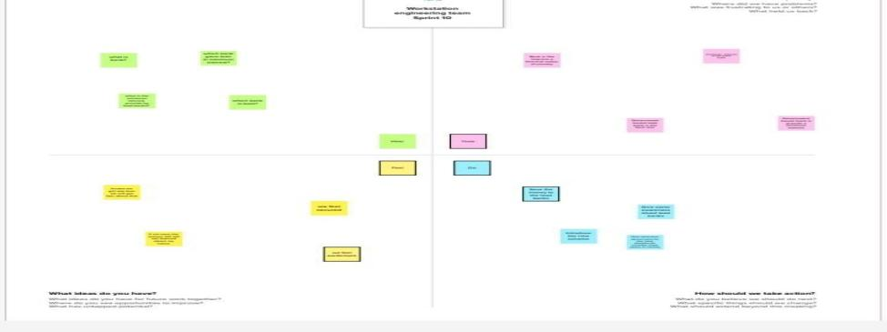

**2.2 Brain Storming**

Brain storming is a group problem-solving method that involves spontaneous contribution of creative ideas and solutions.This technique requires intensive, freewheeling discussion in which every member of the group is encouraged to think aloud and suggest as many ideas as possible based on their diverse knowledge.

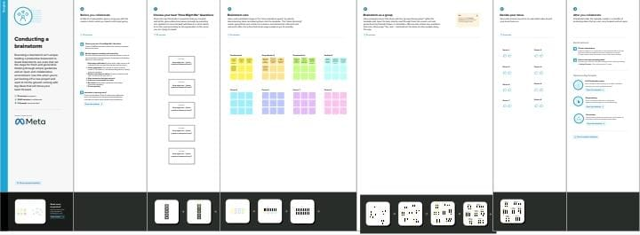

**3.RESULT**

**Data source:**

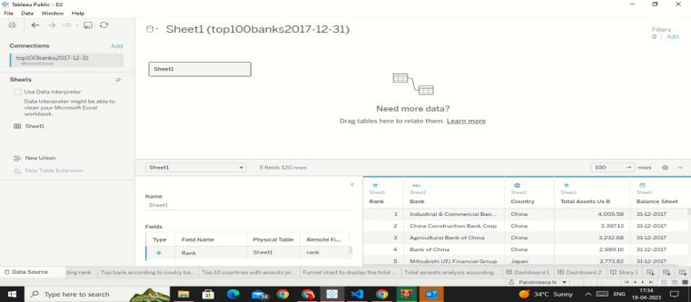

**SHEETS:**

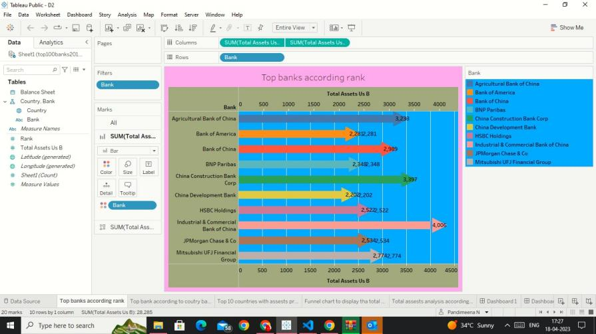

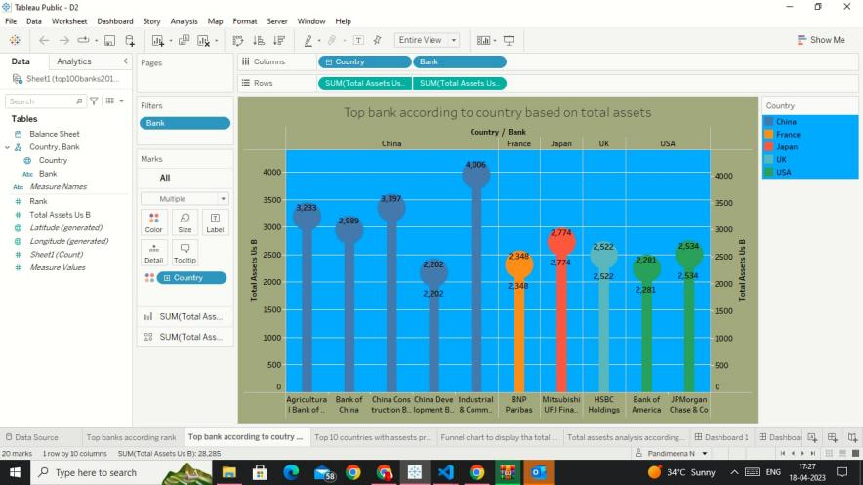

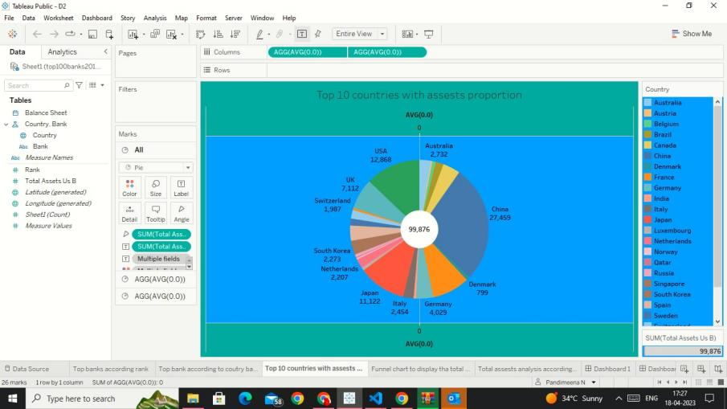

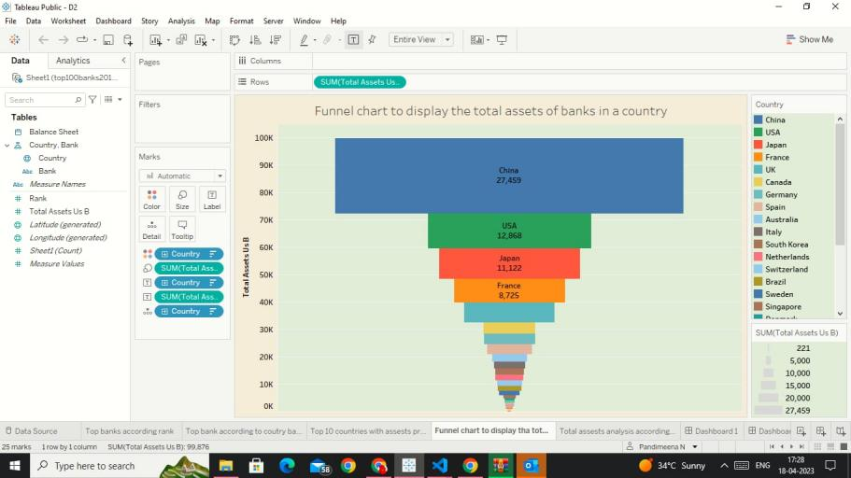

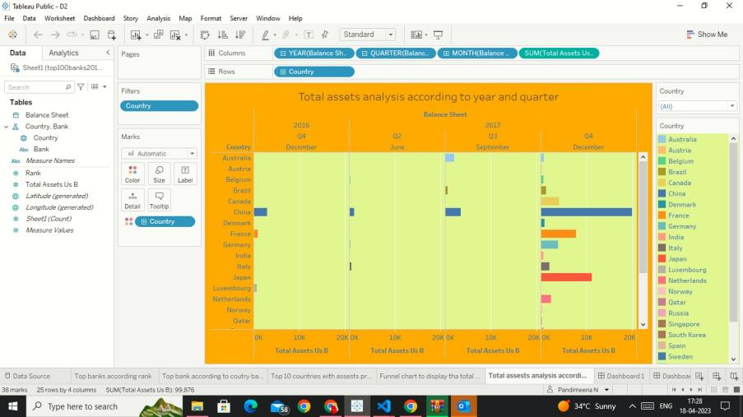

**Dash Board:**

A dashboard is a graphical user interface (GUI)that display information and data in an organized ,easy -to-read format. Dashboard are often used to provide real -time monitoring and analysis of data and are typically designed for a specific purpose or use case

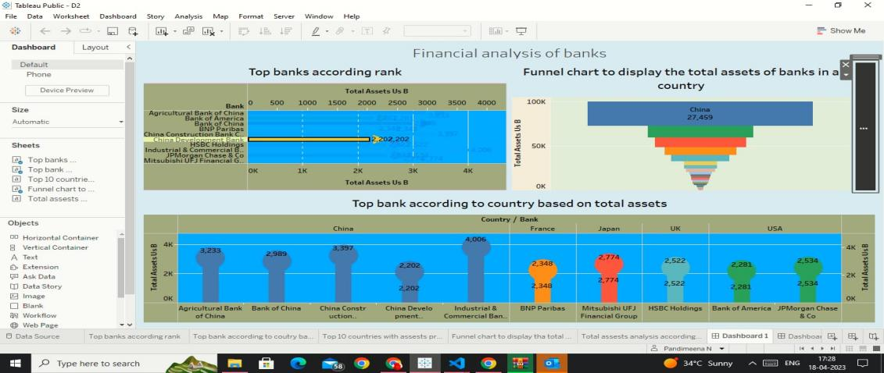

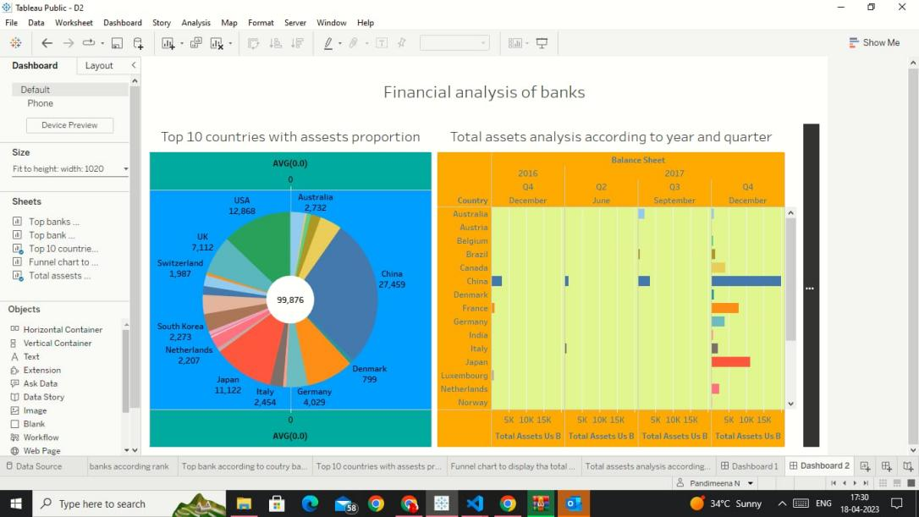

**STORY:**

A data story is a way of presenting data and analysis in a narrative format, intending to make the information more engaging and easier to understand. A data story typically includes a clear introduction that sets the stage and explains the context for the data, a body that presents the data and analysis logically and systematically.

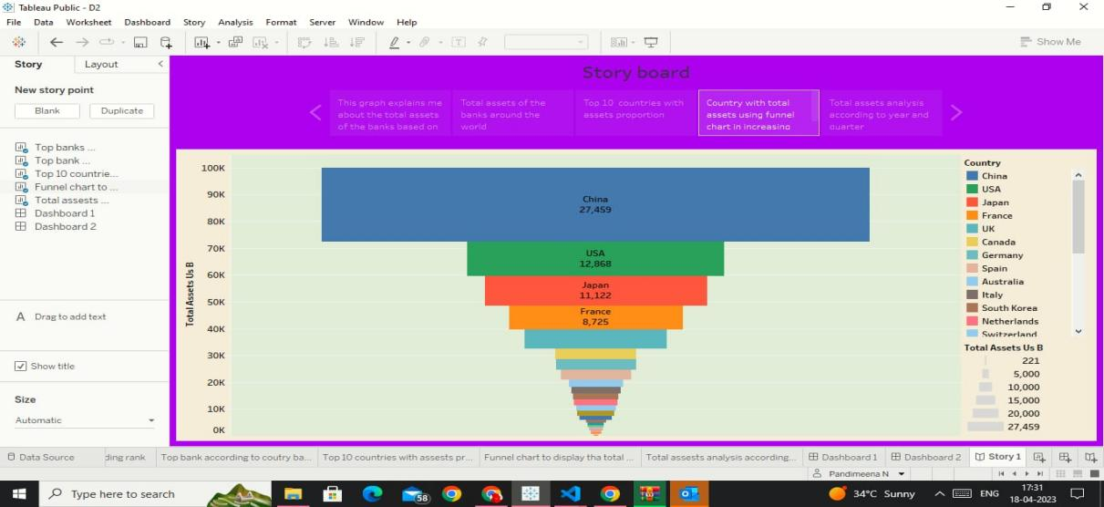

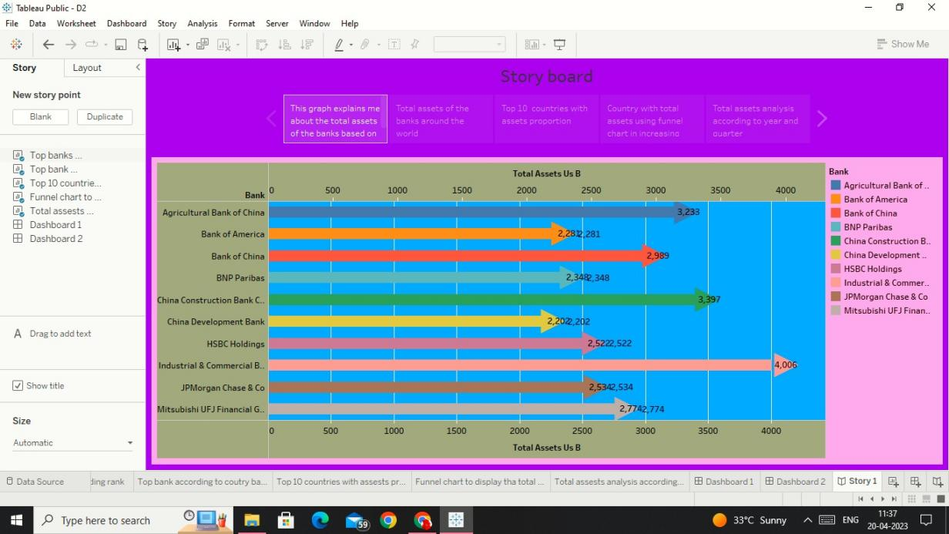

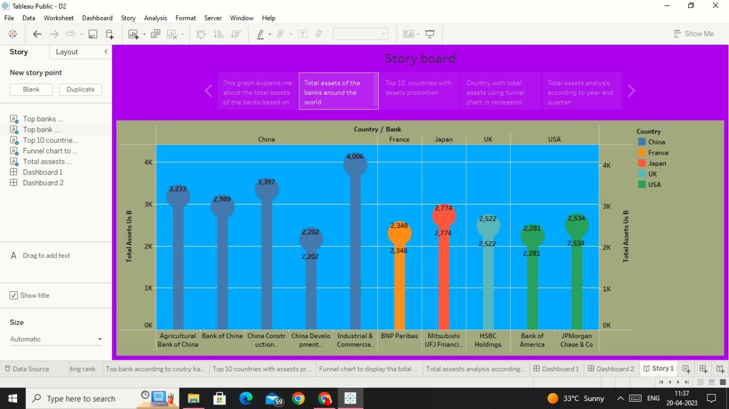

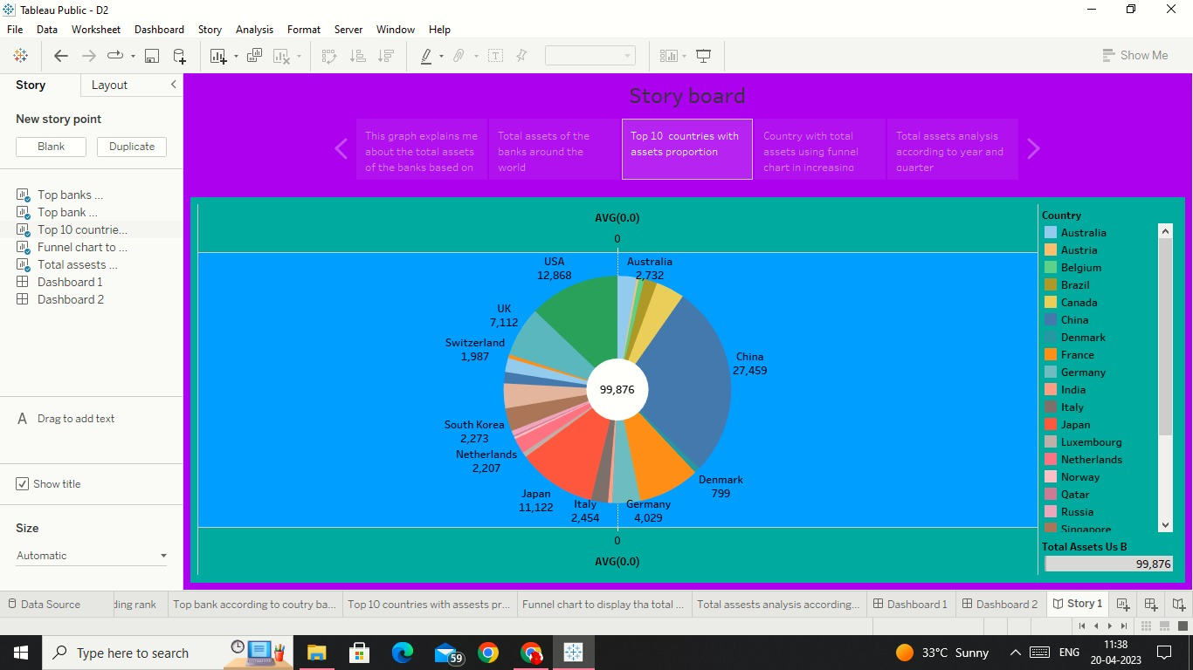

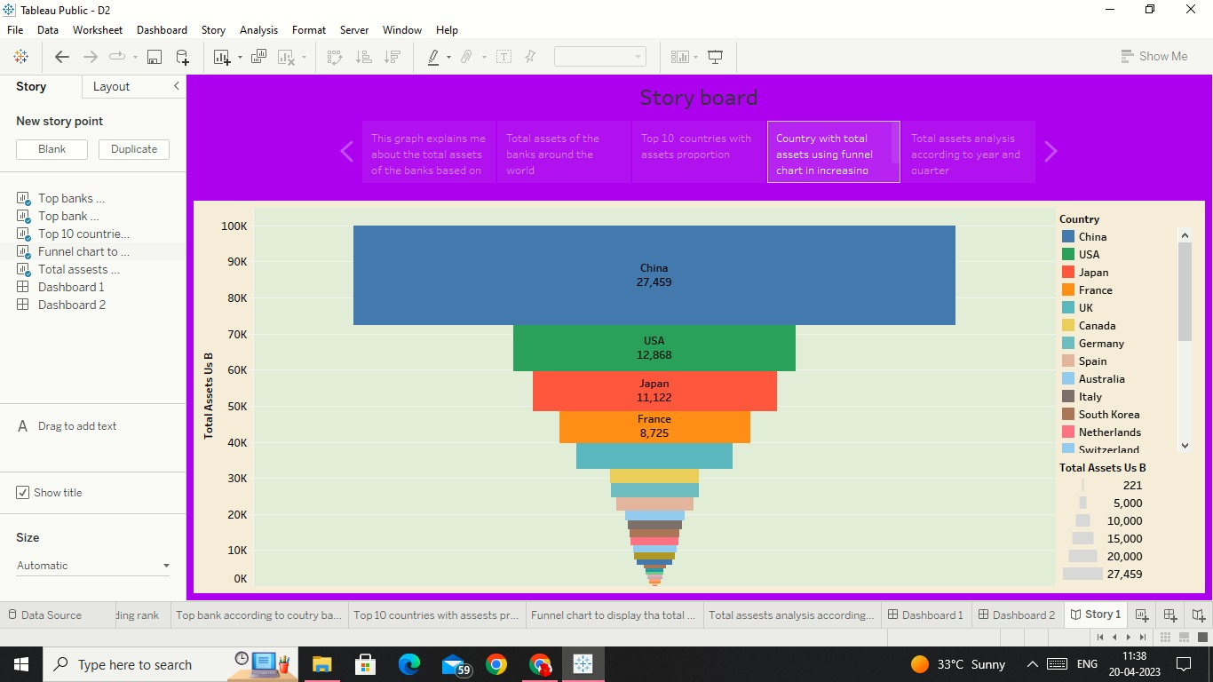

**4.ADVANTAGES & DISADVANTAGES**

* The advantages of the lead bank is spread the availability of banking facilities all over the countries.
* More effective branch expansion. Better relationship between government and banks .
* Integration of credit activities of banks it would be assists in implementation of district plans.
* The disadvantages of the lead bank is shifting policies, complexities in operations and issues shifting to the financial inclusion duplication of efforts in credit plan preparations.
* Absents of check and balance.

**5.APPLICATIONS**

* Acceptance of the deposits from the public.
* Provide demand withdrawal facility.
* Lending feacility.
* Transfer of funds.Issue of drafts .
* Provide costumers with locker feacility.

**6.CONCLUSION**

* As we first read through the entire project. Then we have download the mural and GitHub.
* Next step is collaborate with mural and GitHub
* Next step is form the group discussion with our team members then we have collect the different perspective ideas to put the brain storming and empathy map also
* Then the next step is we collect the small data then collaborate in all of the merge with the big data.

**7.FUTURE SCOPE**

* Banking has emerged as one of the most rapidly growing industries in the country.
* The rapid growth and advancements in the banking sector have paved the way for a wide range of career opportunities in banks**.**
* Every year, hundreds of them retire from their jobs; some will be retiring in the next few years.
* The banks recruit young, eligible candidates to make up for this shortfall.

**8.VIDEO LINK**

**Source code :**

https://drive.google.com/file/d/143wckqraPMxvvSJXDK0PvOabtzQLl7W7/view?usp=drivesdk